Year 1 Easter Paper Wreath
You will need:
Plain paper
Colouring pencils
Glue/sellotape
Craft materials (optional)
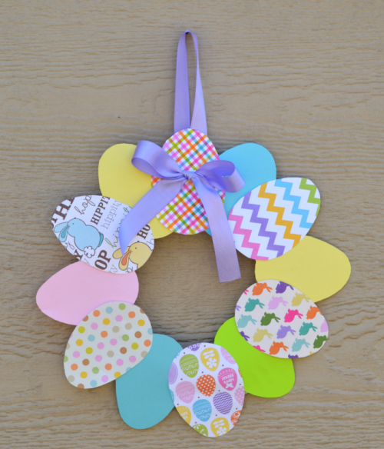
- Draw around an oval shape at home or on Google images to create the shape of an egg.
- Do this 12 times.
- Cut out the oval shapes and decorate them using any media or materials you have at home. Can you make them into 3D eggs?
- Glue or sellotape the eggs together into a wreath shape.
- Add ribbon or string to your wreath to hang it in your home

Take photos and show us what you made when we return back to school!

