Egg Heads
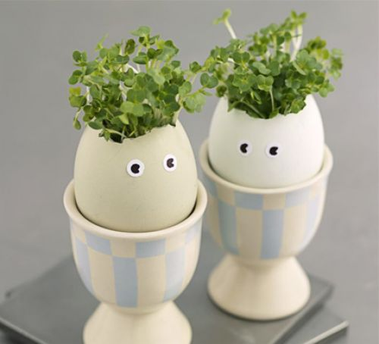

Ingredients
- 2 eggs
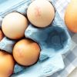

You'll also need
- 2 tsp cress seeds, 2 cotton wool balls, felt-tip pens or acrylic paints

Method
- Carefully remove the tops from the eggs, leaving the bottom two-thirds of the shells intact. Empty the shells (save the eggs for another time), then carefully wash them out. Decorate the shells with pens or paint, then leave them to dry.
- Dip the cotton wool balls in a little water, squeezing off any excess. Place 1 ball inside each shell, then sprinkle 1 tsp cress seeds onto each one. Sit the filled shells in eggcups and leave in a dry, well-lit place for a week – a windowsill is perfect. Your cress will start to grow within a few days, perfect for making egg & cress sarnies!

