Egg Weaving
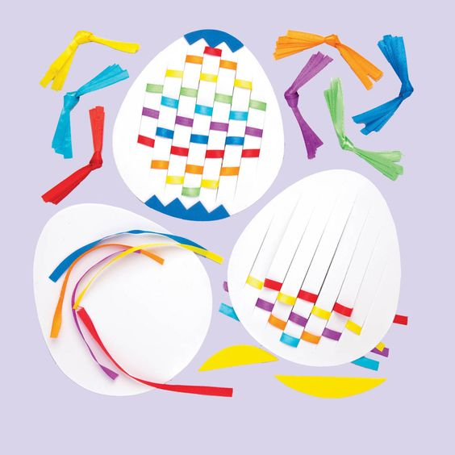
Recycling Tip: Use strips by cutting up plastic bags or magazines.
Here is an egg template:
