Maths Activity

Learning objective - to reinforce length
Activity – can you make 2 caterpillars of differing lengths out of cut out circles.

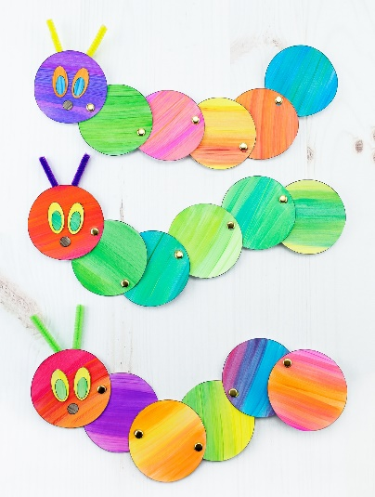
Using different objects from around your home e.g lego, stones, leaves, cars etc, measure the length of your caterpillar.
NB – in EYFS we start measuring using nonstandard units because children need to understand that nonstandard units means that everybody’s measurements are different and that standard units are essential so that everybody is measuring in the same way. This will be explored more in year 1. Therefore, it is important to not miss out this stage of their mathematical development.

Can you upload your findings on virtual@beaudesert.school. We can then provide you feedback!

