Maths Plan Examples

Step 1 – Counting in ½’s
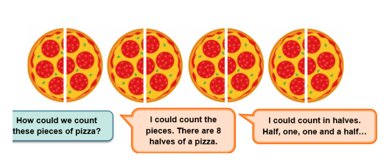

Counting in ¼’s

Greater depth challenge
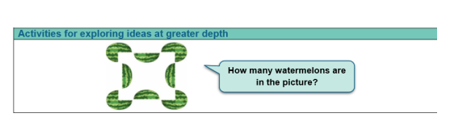
Step 2 – counting in halves on a number line.
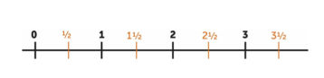

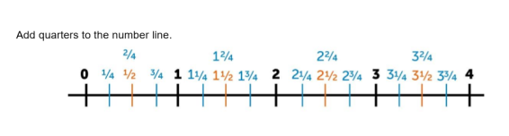
Step 4 – Fractions of capacity
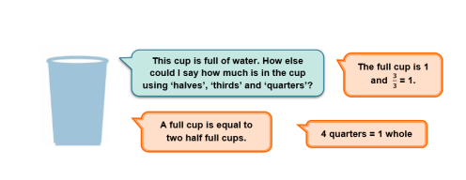

Greater depth challenge

